**Overview:**

Everywhere you travel there is an abundance of sensors, collecting data continuously with the hope it can recorded and processed demonstrating trends or states of their environments.

In Building 11 (this building) if you look above you when you walk around you might notice a box with what looks like wires pouring out of it like this:

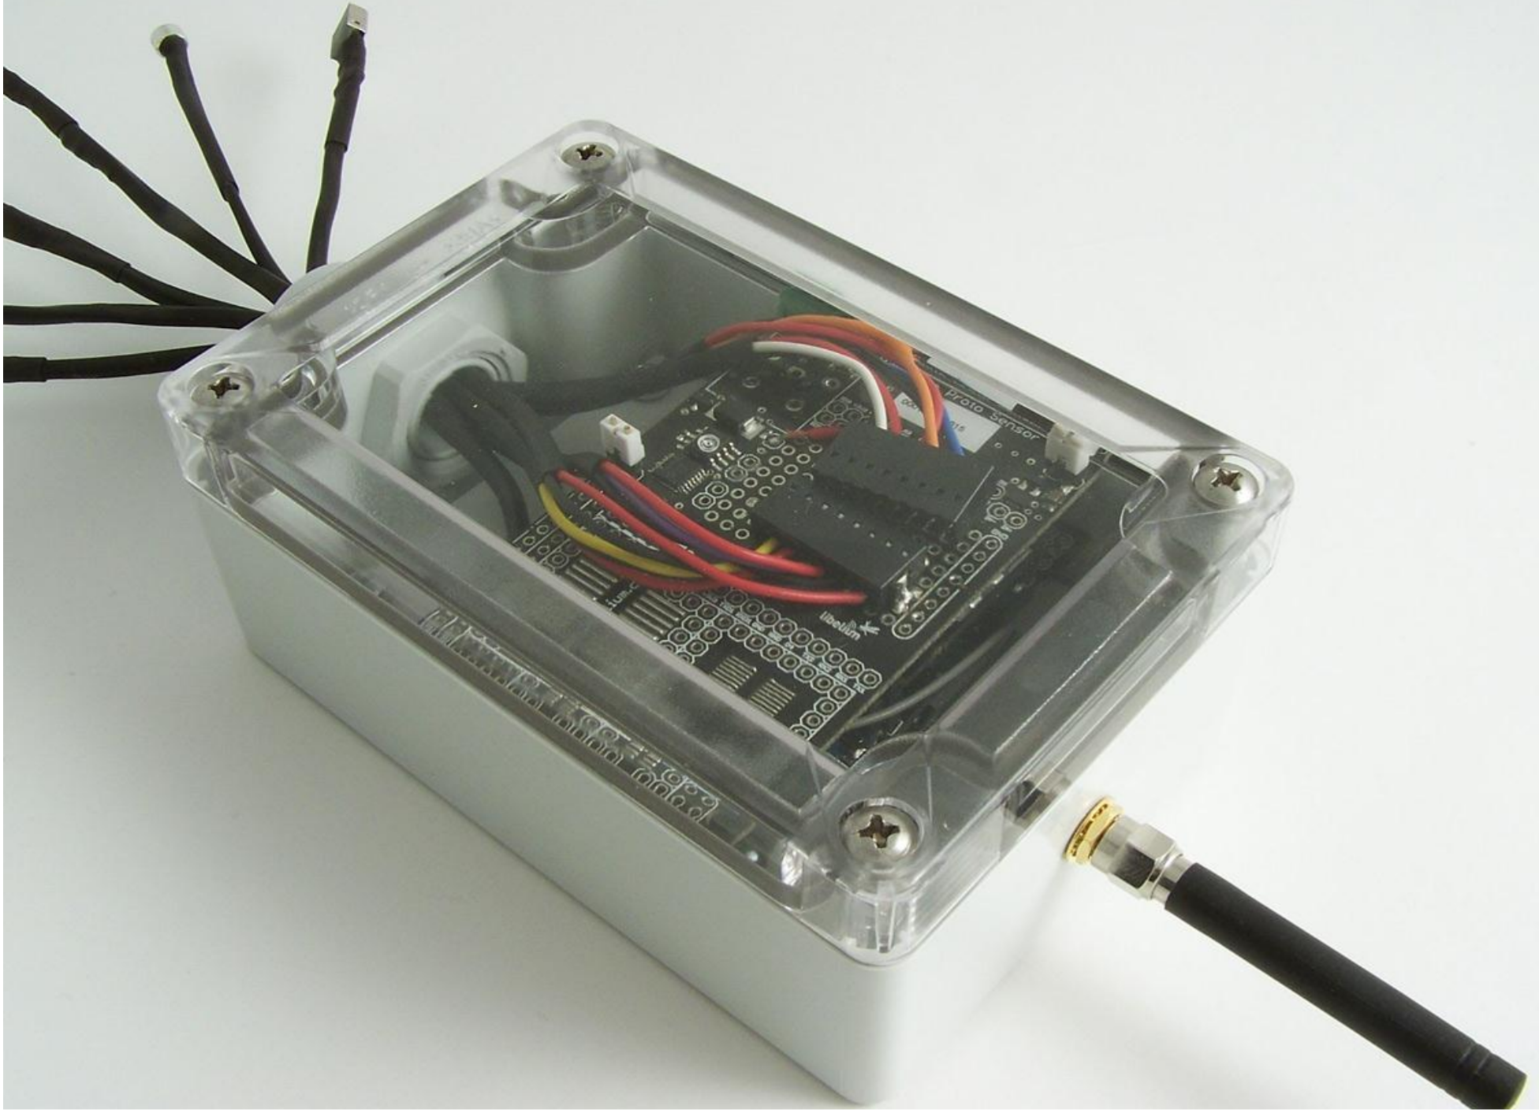

This is actually a collection of sensors used to monitor the environment at UTS! The data is readily available if you’re interested to see here:

[**https://tinyurl.com/sd82lht**](https://tinyurl.com/sd82lht)

Essentially we are going to try and make our own device that can read values from sensors just like this one! But first we need to cover the basic before we build**, research and fill out below as shown:**

|  |  |  |  |
| --- | --- | --- | --- |
| **Sensor Name** | **Image** | **Wiring Configuration** | **Output and Data Type** |
| Temperature Sensor | *image yet to be inserted* | Image result for temperature sensor wiring raspberry pi" | Temperature (Float) |
| Ultrasonic Sensor | *image yet to be inserted* |  |  |
| PIR Sensor | *image yet to be inserted* |  |  |
| LED | *image yet to be inserted* |  |  |
| Push Button | *image yet to be inserted* |  |  |